LASER BASICS

INSTALLATION AND RECOMMENDATIONS

FOR

BLOWER REQUIREMENTS



BLOWERS

THROUGH OUR RESEARCH WE HAVE ESTABLISHED GUIDELINES ON THE PROPER CFM RATINGS REQUIRED FOR THE EXHAUST SYSTEM. THESE RATINGS ARE BASED ON THE MEASURED DISTANCE BETWEEN THE EXHAUST OUTLET ION THE LASER SYSTEM AND THE INLET OF THE EXHYAUST BLOWER. WE HAVE FOUND A SUITABLE SUPPLIER FOR THIS TYPE OF EQUIPMENT IF YOU CHOOSE NOT TO USE THIS SUPPLIER, PLEASE ENSURE THAT THE BLOWER THAT YOU PURCHASE MEETS OR EXCEEDS THE FOLLOWING SPECIFICATIONS:

DISTANCE BETWEEN BLOWER AND LASER | CFM RATING AT 6 INCHES STATIC PRESSURE | GRAINGER CATALOG #
UP TO 7 FEET | 235 @ 6 INCHES STATIC PRESSURE | 7C182*
8 – 14 FEET | 410 @ 6 INCHES STATIC PRESSURE | 7C183*
15 – 22 FEET | 535 @ 6 INCHES STATIC PRESSURE | 7C184*
25 – 30 FEET | 625 @ 6 INCHES STATIC PRESSURE | 7C185*

*THESE BLOWERS COME EQUIPPED WITH A WEATHER PROOF COVER. THE ADDITIONAL COST OF SHELTERING THIS BLOWER WILL NOT BE NECESSARY.

5 FOOT RUBBER HOSE KIT – GRAINGER PART # 1Z890

IF YOU WOULD LIKE TO PLACE AN ORDER FOR A BLOWER OR WOULD LIKE TO RECEIVE A CATALOG OR THE NAME OF THE CLOSET DEALER, PLEASE CALL

GRAINGER CORPORATION
1-800-323-0620
OR FAX
1-800-722-3261

DUCTWORK, FITTINGS, REDUCERS, SHUT-OFF GATES

THESE ITEMS CAN BE PURCHASED FROM:

McMaster-Carr Supply Co.
P.O. Box 4355
Chicago, IL 60680-4355
(708) 833-0300
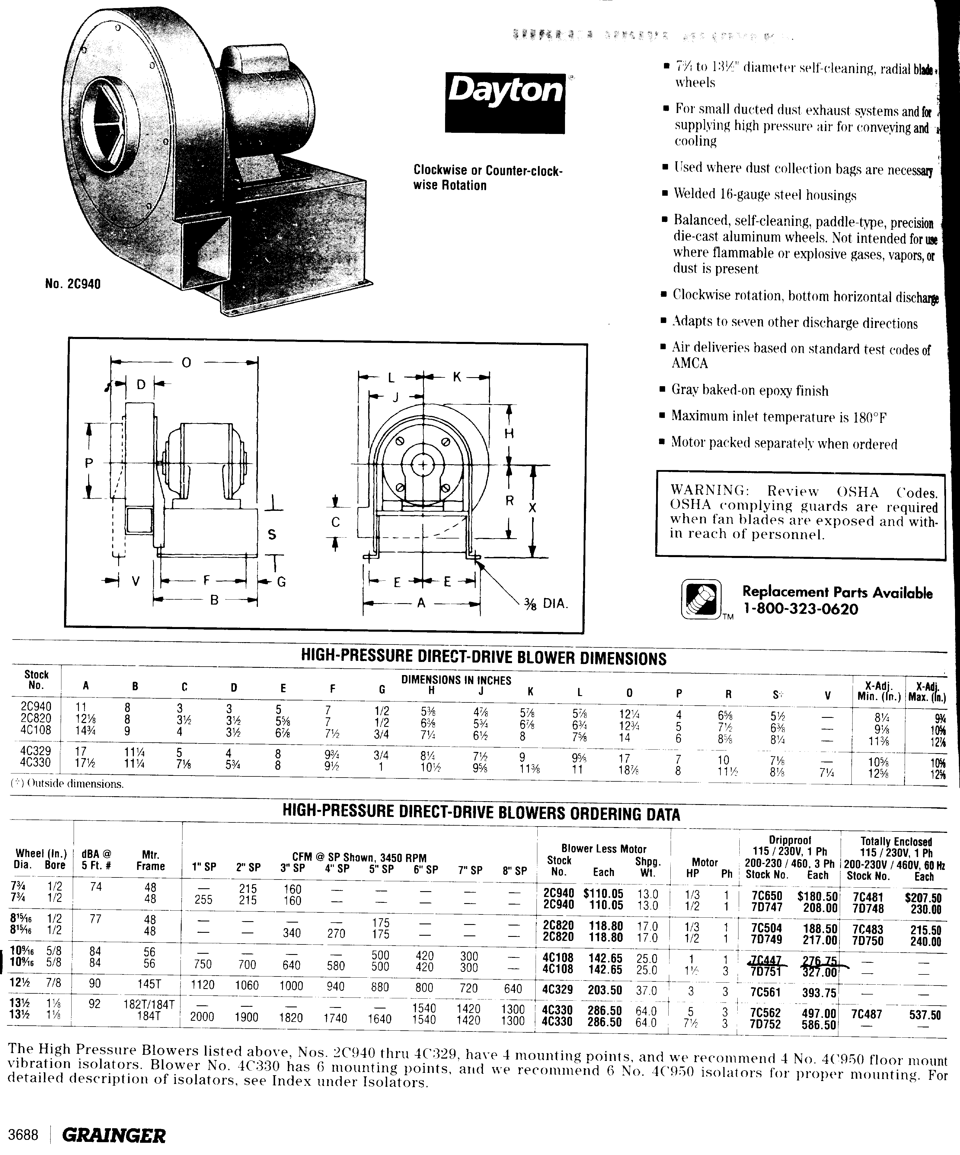

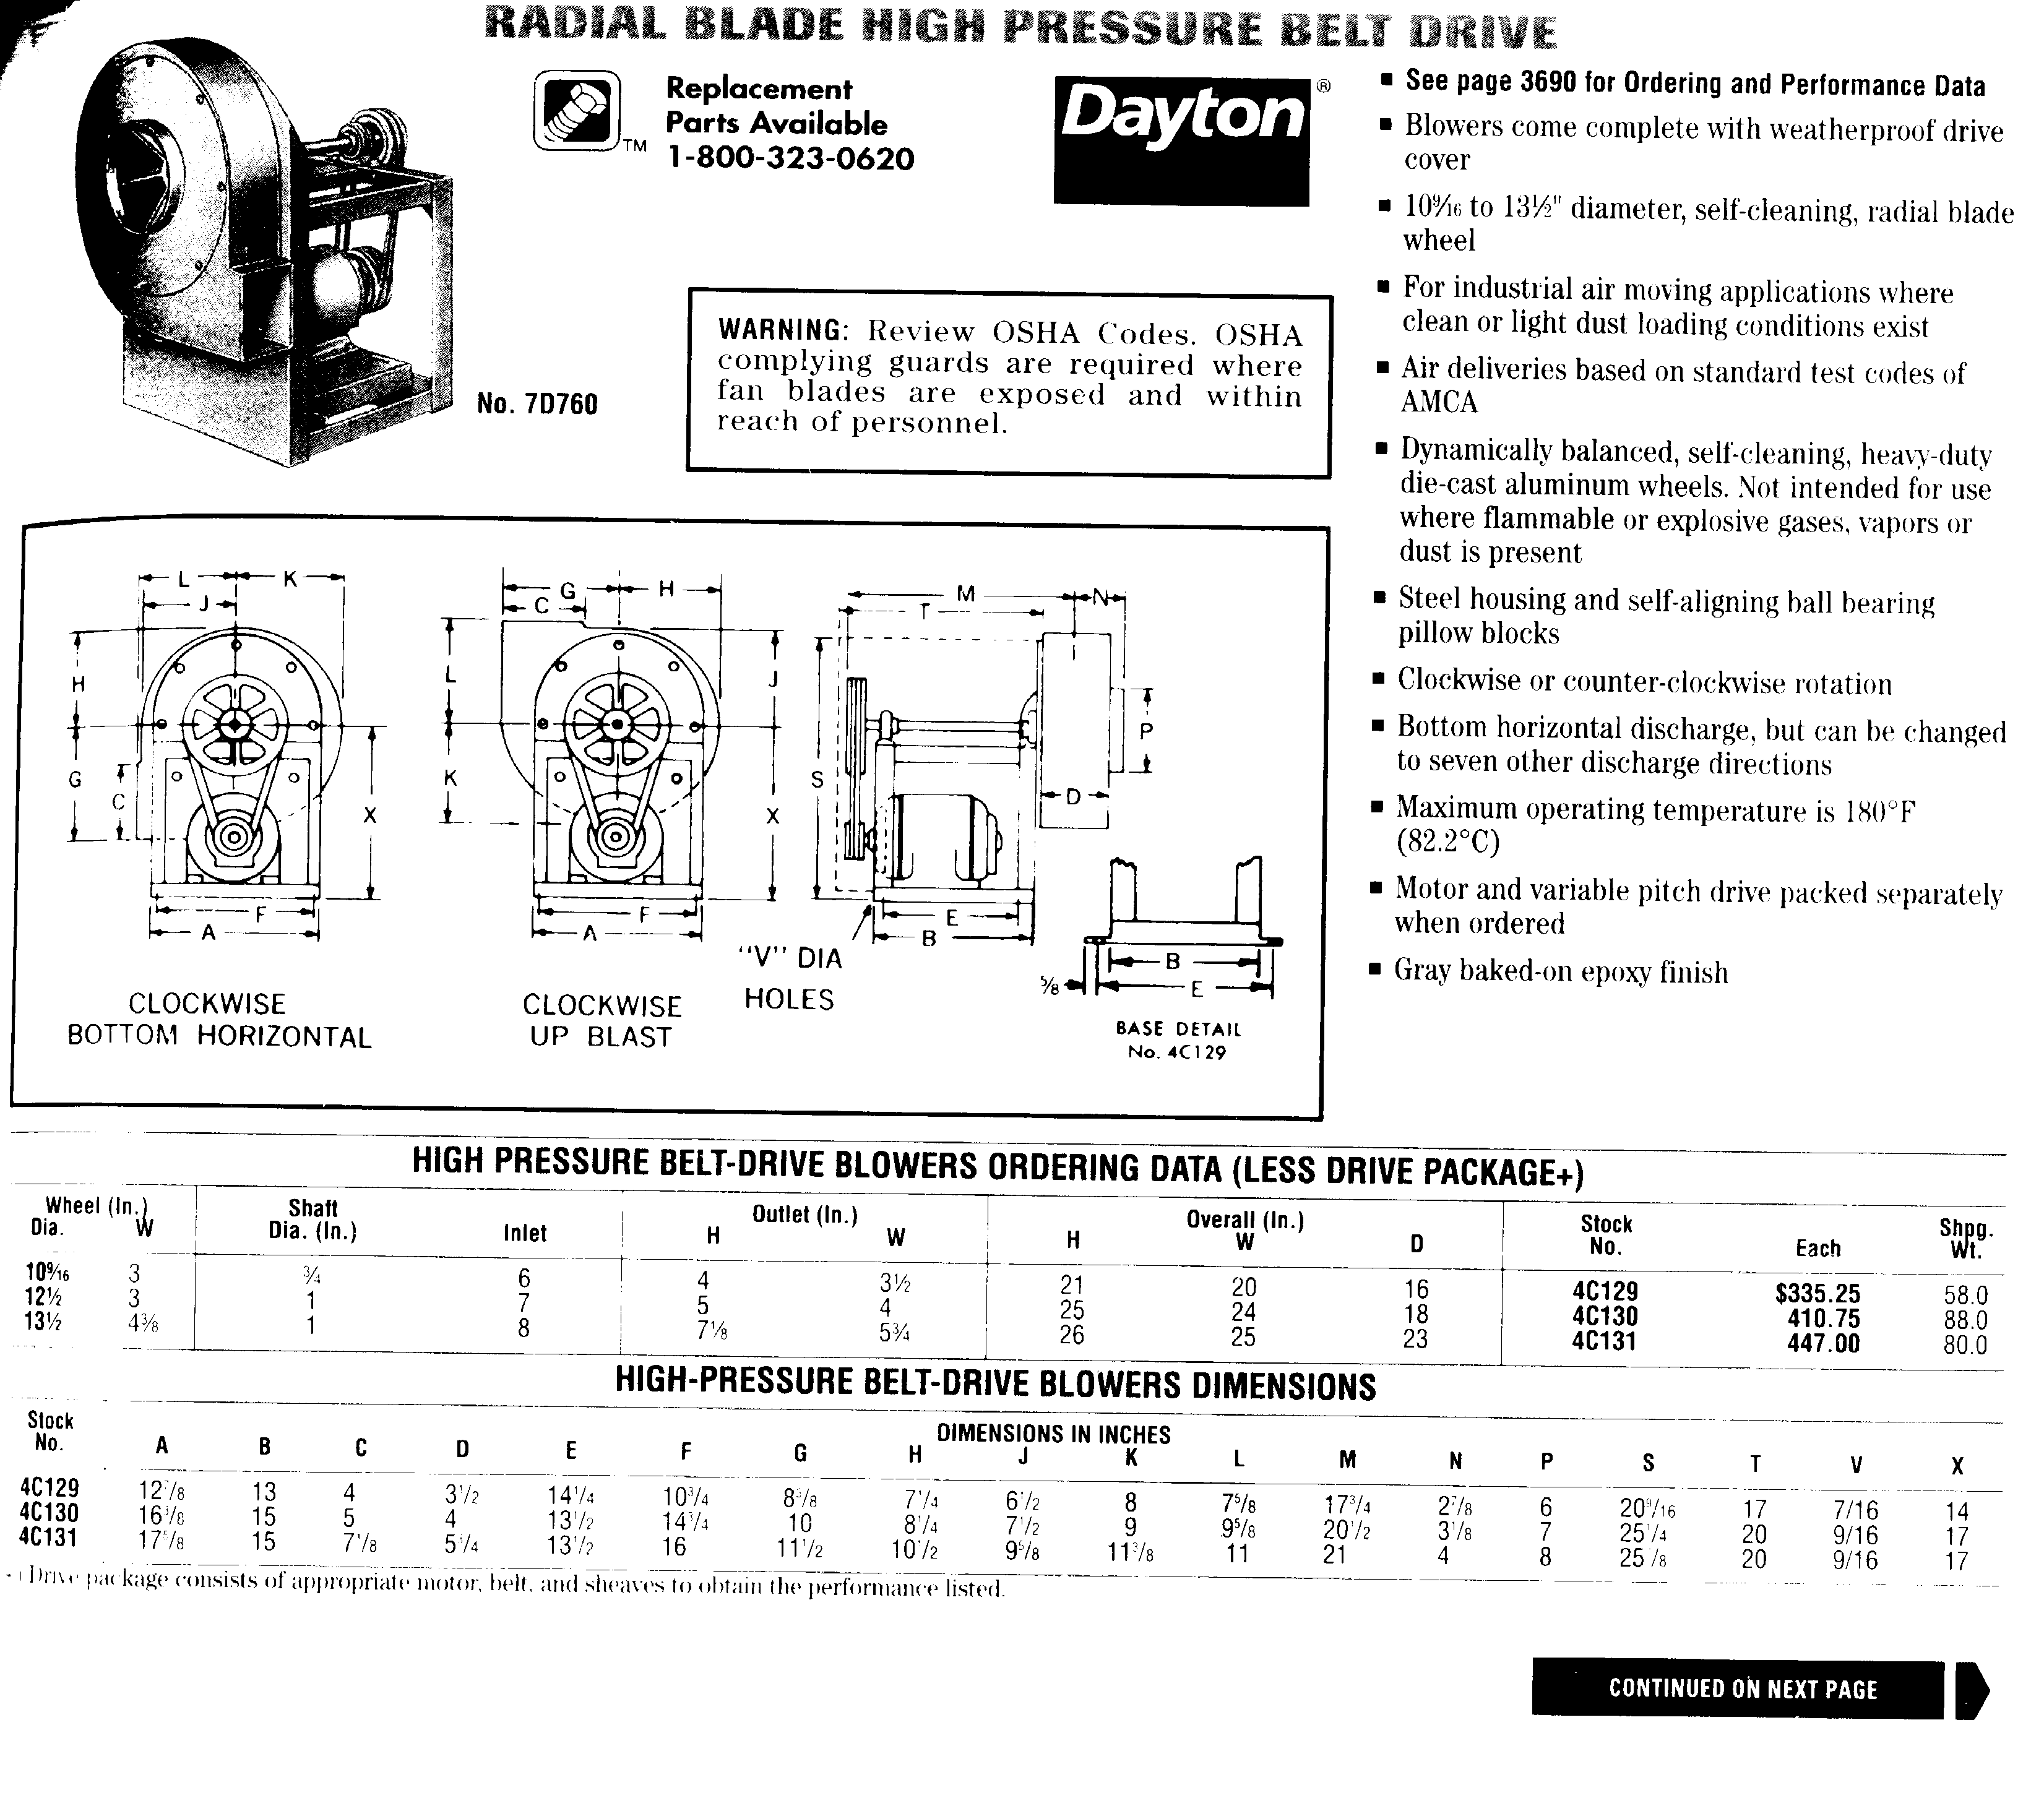
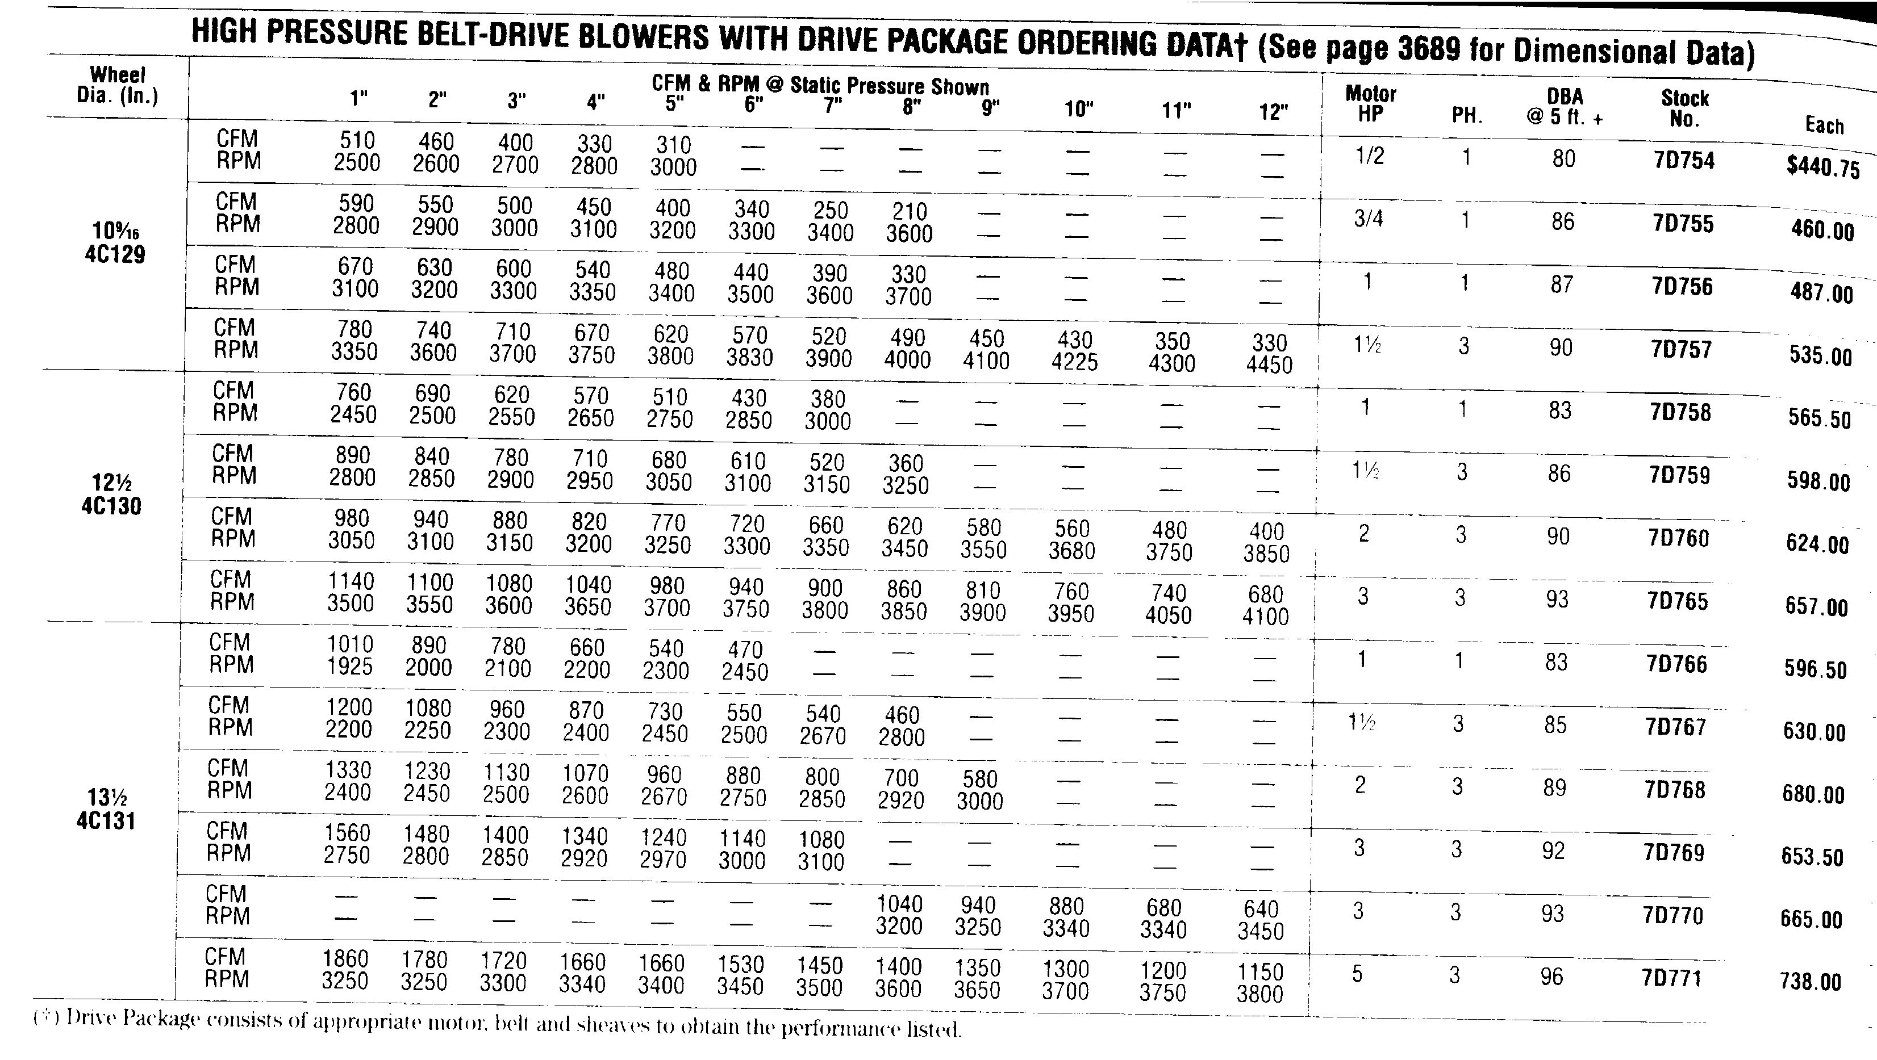

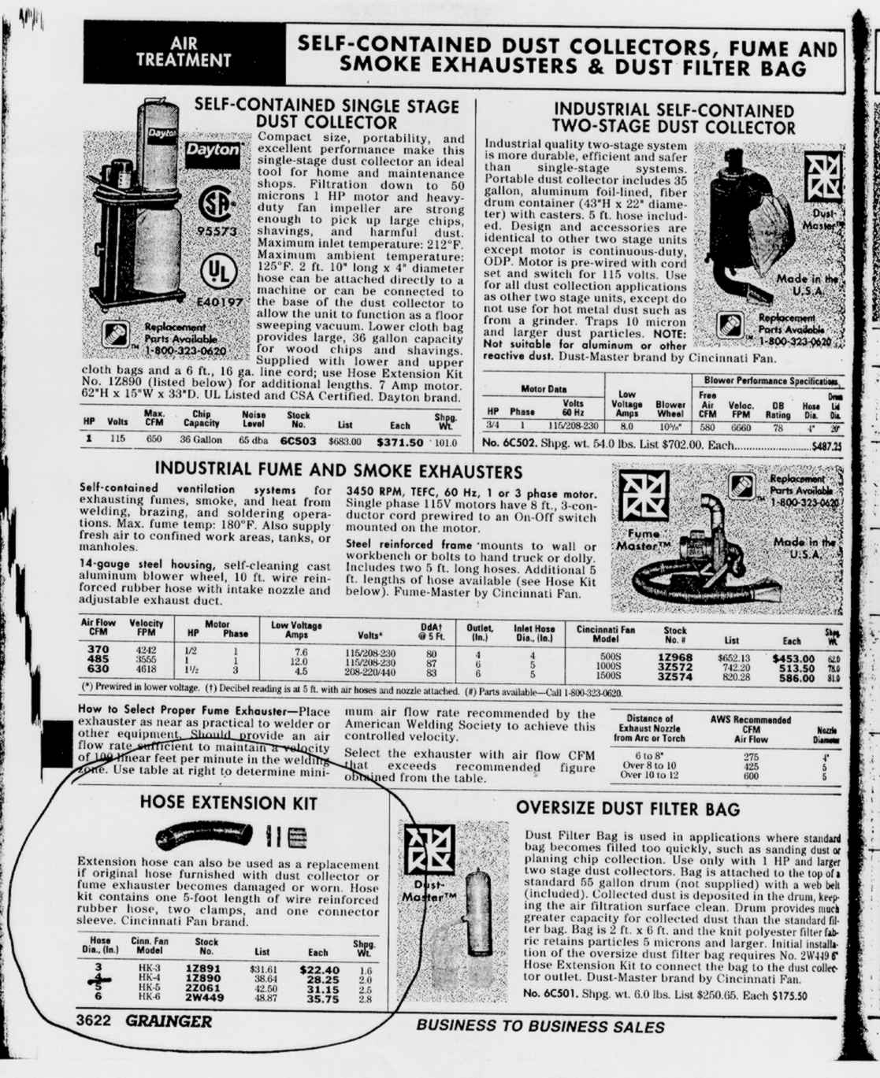

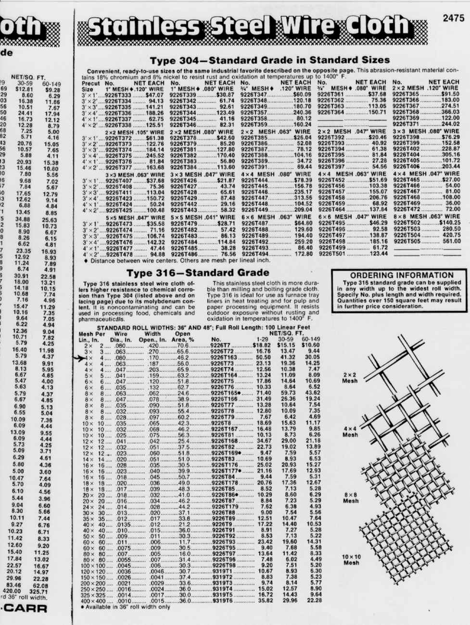

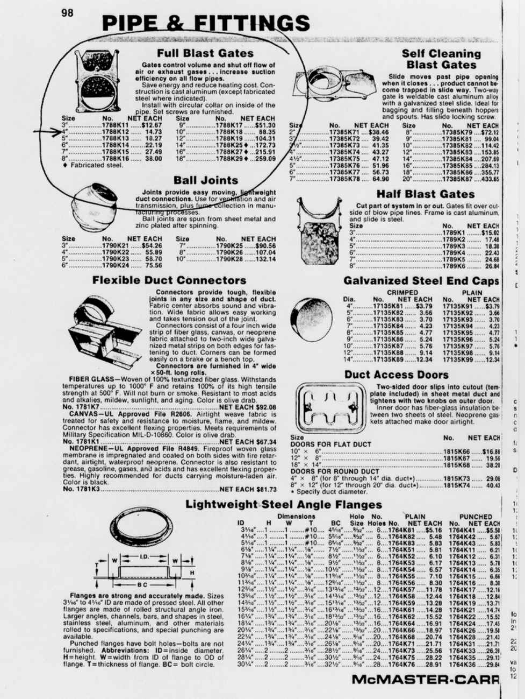

TYPICAL ROOF MOUNT

FOR

BLOWER INSTALLATION

NOISE SUPPRESSION

IDEAS ON HOW TO
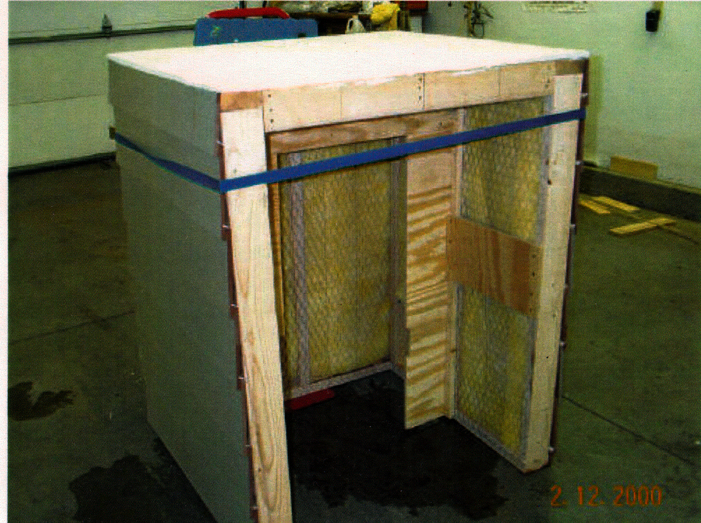
REDUCE BLOWER NOISE

